Register on IBM

Fertilizers Recommendation System For

Disease Prediction

Sonakshi.G

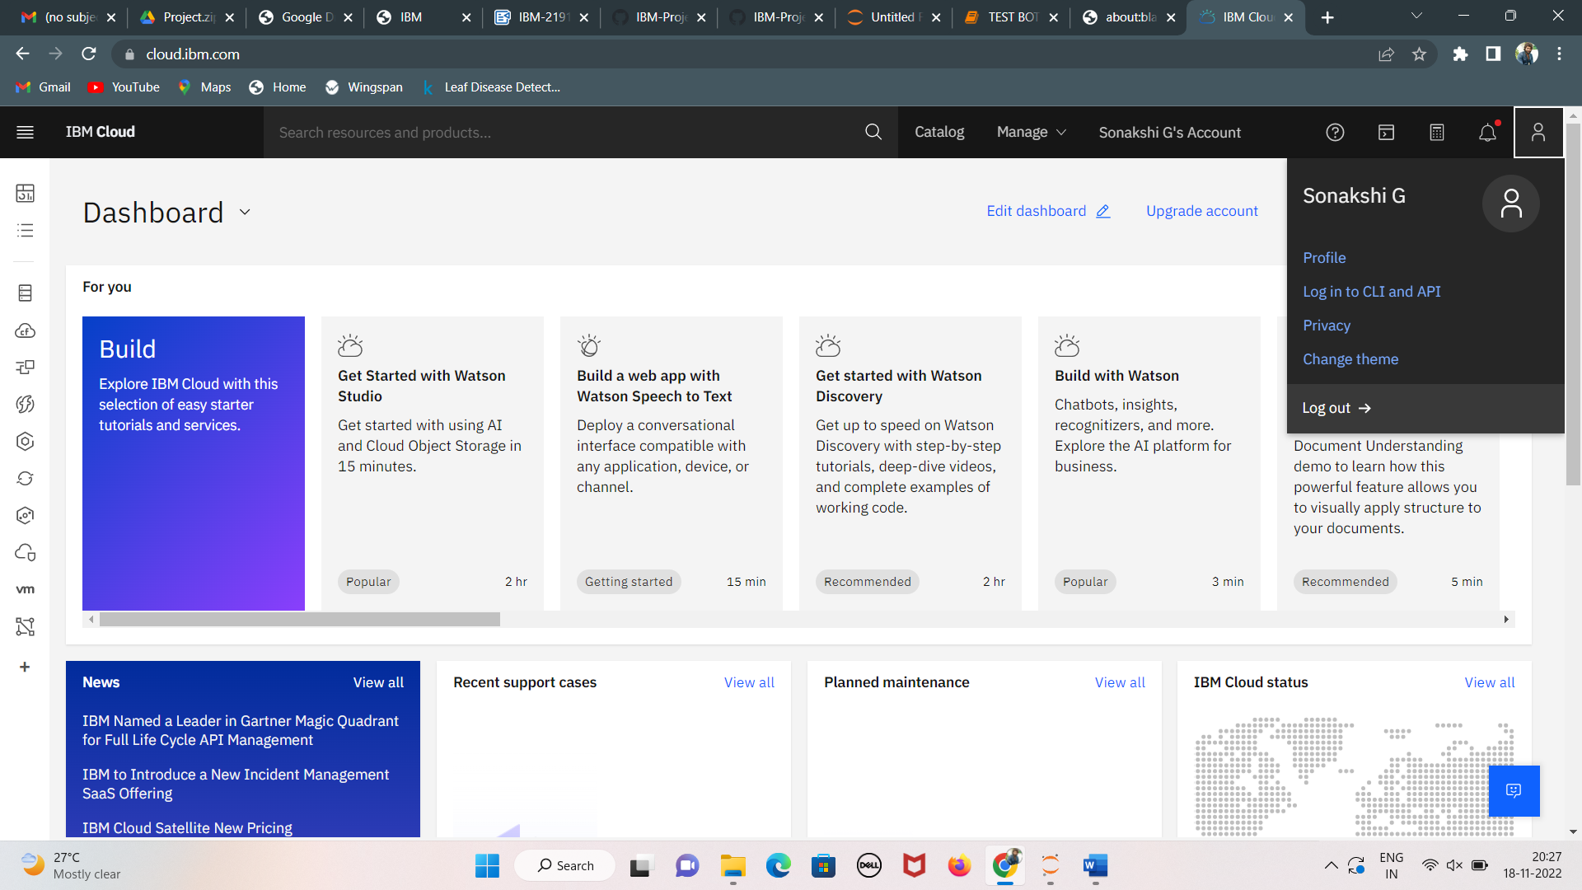

Manusha.R

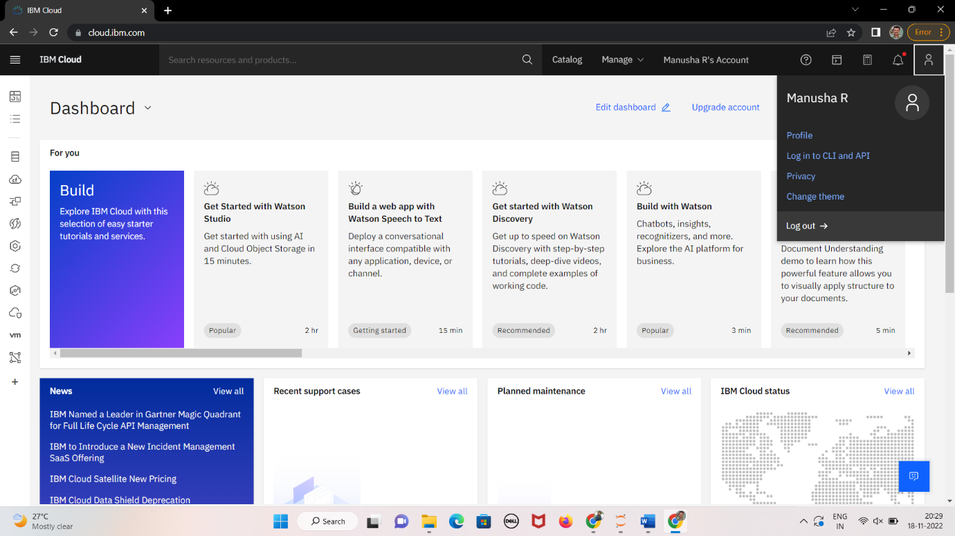

Sindhu.S

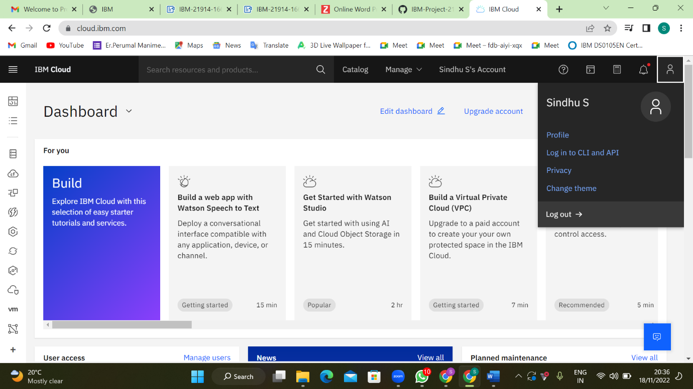

Jagathi.S

